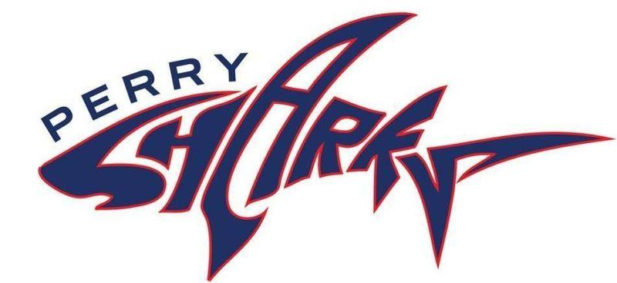
The Friends of the Perry School

January 1, 2024

Dear Community Member:

On Saturday, March 23, 2024, the Friends of the Perry School will host our sixth annual Perry Rocks fundraiser in South Boston to benefit the Oliver Hazard Perry K-6 School. This event will bring together a cross section of Boston residents, including local business owners, city officials, and parents who are all dedicated to supporting this amazing Boston Public School. This year, we will celebrate the impact that Ryan Barrett has had on the Perry School by honoring her with the 2024 Great Perry Shark award. The Oliver Hazard Perry K-6 School is a small gem of a school located across the street from M Street Beach in South Boston. It is a unique and innovative school with amazing teachers, a tight-knit community of families and a strong curriculum. As a small school, the Perry has a limited budget. This makes fundraising vital to helping our teachers and students excel.

During Perry Rocks we will have a silent auction to raise money for our students. A donated item or experience would be greatly appreciated and we would love to have your showing of support at our fundraiser. Funds from The Perry Rocks event will go to support the Perry K-6 School and will provide funding for programs and opportunities that may otherwise be unavailable to our students. The funds raised this year will be dedicated to enhancing our school community in three key areas: school-yard and outdoor classroom improvements, the Literacy program, and in sponsoring arts & music initiatives school-wide.

The Friends of the Perry’s 501(c)3 federal tax identification number is 82-3025265. For further information, please visit our website at www.perryschoolboston.org, our Facebook and Instagram pages @FriendsofthePerry, or contact me at Courtney.Subatis@gmail.com. We look forward to hearing from you and thank you in advance for your support of the Perry School.

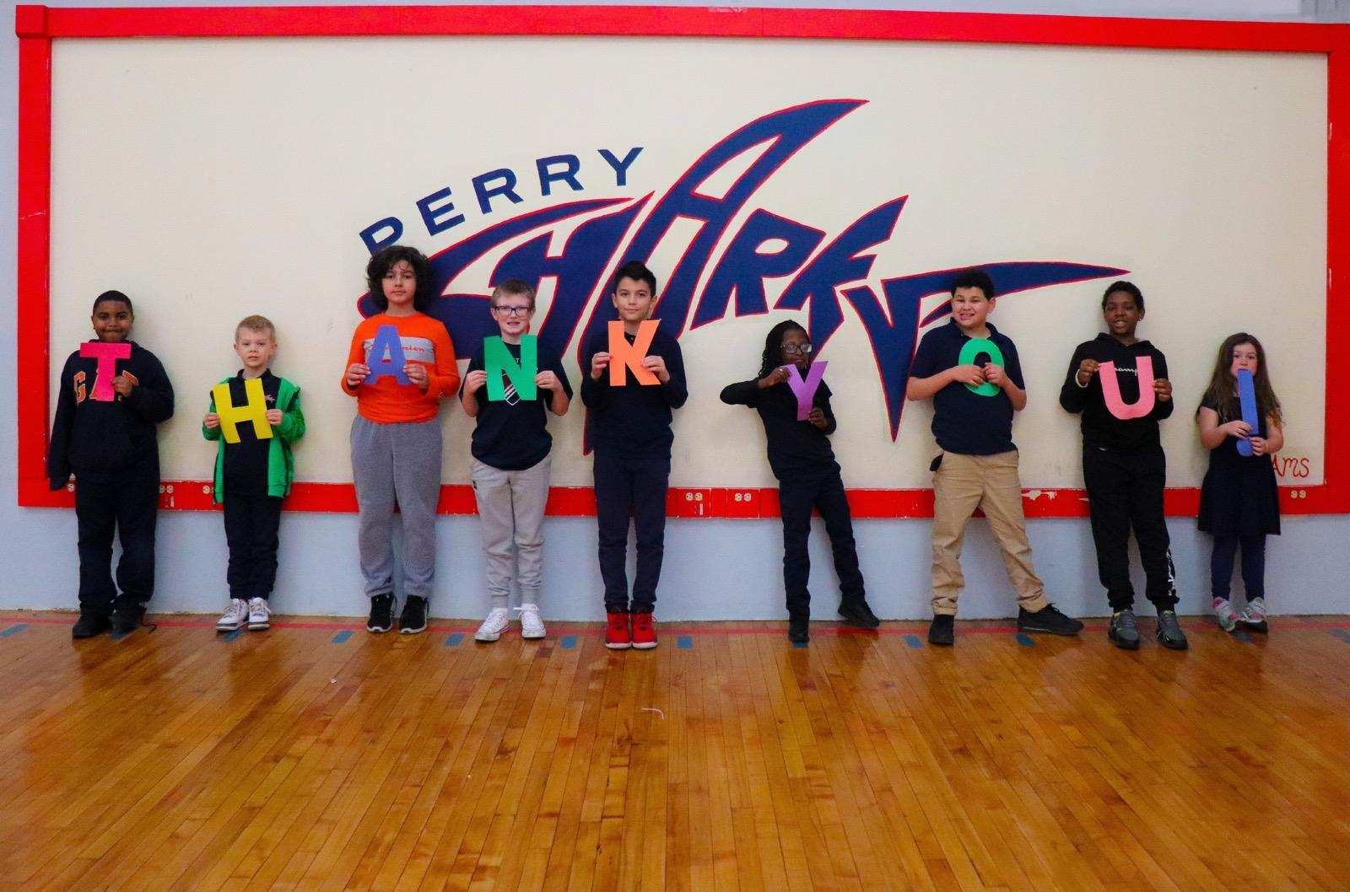
Sincerely,

Courtney Subatis
President
Friends of the Perry School 501c3
PO Box 51671
Boston, MA 02205

