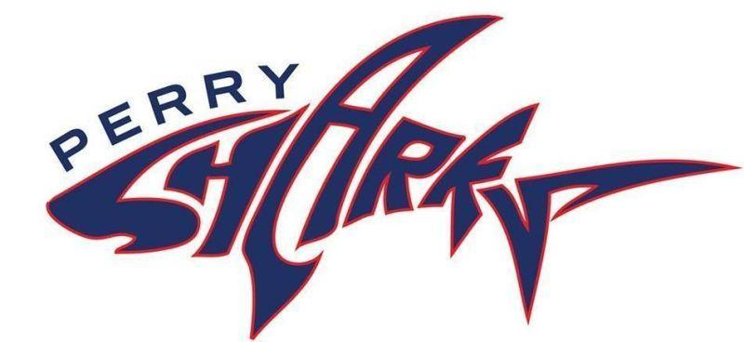
The Friends of the Perry School
January 1, 2024

Dear Community Partners:

The Friends of the Perry School would like to invite you to the annual Perry Rocks fundraiser on Saturday, March 23, 2024 at The Lithuanian Club on West Broadway in South Boston. This event will bring together a cross section of Boston residents, including local business owners, city officials, and parents who are all dedicated to supporting this amazing Boston Public School. This year, we will celebrate the impact that Ryan Barrett has had on the Perry School by honoring her with the 2024 Great Perry Shark award.

The Oliver Hazard Perry K-6 School is a small gem of a school located across the street from M Street Beach in South Boston. It is a unique and innovative school with outstanding teachers, a tight-knit community of families, and a strong curriculum. As a small school, Perry has a limited budget. This makes fundraising vital to helping our teachers and students excel. Funds from the Perry Rocks event will support the Perry School and provide funding for programs and opportunities that may otherwise be unavailable to our students. The funds raised will enhance the education of Boston children by advancing Arts and Music in the school, improving the school yard and outdoor classroom, furthering our Literacy program and sponsoring many enrichment activities such as school-wide yoga classes. For further information, please visit our website at www.perryschoolboston.org, our Facebook and Instagram pages @FriendsofthePerry, or contact me at amanda.nicole.harper@gmail.com.

We hope you will consider joining us to thank our honoree, Ryan Barrett, and the promising young children that attend the Perry School at one of the sponsorship levels outlined in the enclosed materials. Sponsors will receive tickets to the event and have the option to be recognized during the award presentation that evening, on social media leading up to the event, and on the Perry School website. Please complete the enclosed sponsorship form and email it with your tax-deductible gift by March 17, 2024 to ensure proper recognition. Thank you for your consideration.

We look forward to hearing from you and thank you in advance for your support of the Perry School.

Sincerely,

Amanda Harper
Friends of the Perry School Parent Volunteer
PO Box 51671
Boston, MA 02205
2024 Perry School ROCKS Sponsorship Levels

Diamond | $5,000 | Funds instrumental music instruction for 15 students for one school year
Includes Platinum Sponsorship level benefits PLUS:
- 4 more tickets to the Perry School Rocks event (8 tickets total)
- Recognized and thanked as a school sponsor during whole school performances
Platinum | $2,500 | Fund one classroom library
Includes Gold Sponsorship level benefits PLUS:
- 2 more tickets to the Perry School Rocks event (4 tickets total)
- Recognized and thanked during the presentation of the Great Perry Shark award
Gold | $1,000 | Funds a spring Field Day for the entire school
Includes Silver Sponsorship level benefits PLUS:
- A second ticket to the Perry School Rocks event (2 tickets in total)
- Recognized as an event sponsor in any printed media coverage of the event
Silver | $500 | Provides one field trip for one class in the Greater Boston area
Includes:
- 1 ticket to the Perry School Rocks event
- Acknowledgement as an event sponsor on sponsorship boards, on Friends of the Perry social media and the Perry School website

Please email Amanda Harper (amanda.nicole.harper@gmail.com) by March 17, 2024 to secure your sponsorship so that proper acknowledgement may be given in all signage and publicity for the event., In your email, please list the following information: sponsorship level, name (as you would like it to appear in all printed materials), and when appropriate, please include a jpeg of your logo.

You may make your gifts through our website our event page or by check. Please mail checks to PO Box 51671 Boston, MA 02205 by March 17,2024.
The Friends of the Perry 501(c)3 federal tax identification number is 82-3025265.

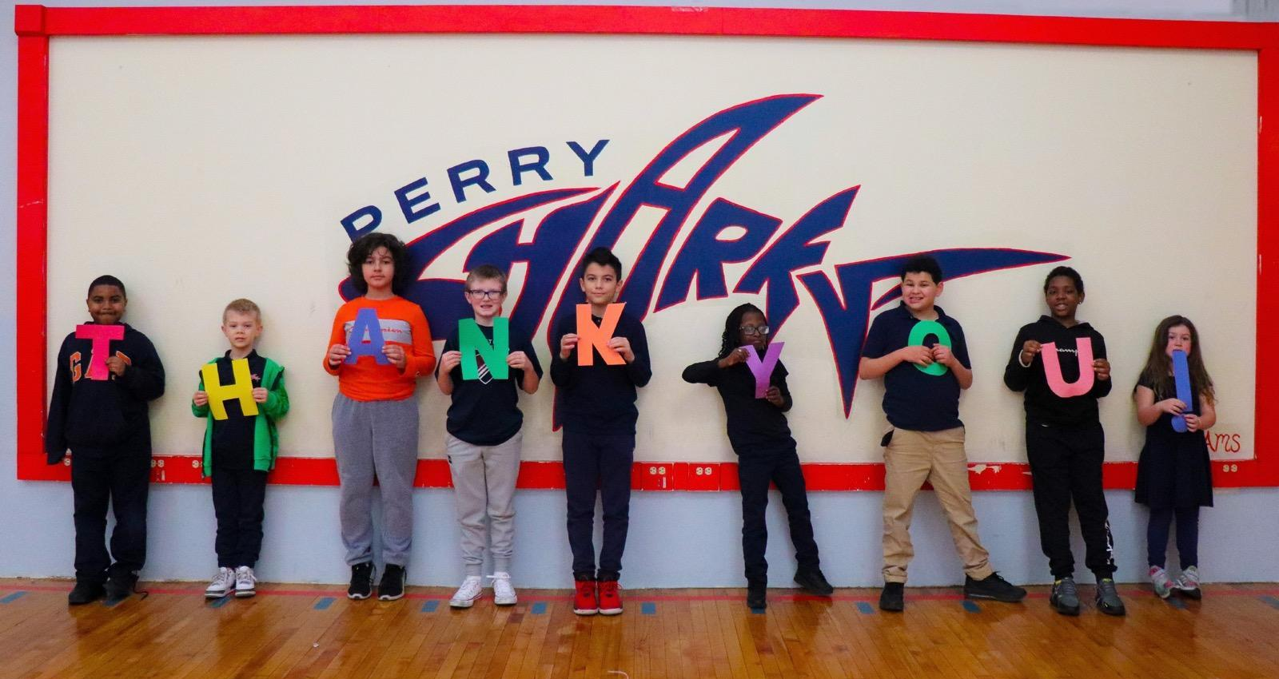
Thank you for supporting the Perry K-6 School!

